Open Licensing Checklist

Use this checklist to make sure your resource meets the requirements for Creative Commons licensing. Be sure to review the checklist BEFORE you begin development work so that you are designing your resource with open licensing requirements in mind from the beginning.

# Checklist

* All graphics (charts, pictures, clip art) are openly licensed or in the public domain.
* All written content is original, openly licensed, in the public domain, or you have obtained written permission to use.
* An attribution statement for any outside content has been included. This attribution includes the title (if known), author, license and links to those items. Place attributions underneath outside content when possible. Otherwise, include an attributionsheading at the end.

Example:

[CK-12 Biology for High School](https://flexbooks.ck12.org/cbook/ck-12-biology-flexbook-2.0/) by[CK-12](https://www.ck12.org) is licensed under a [Creative Commons Attribution-NonCommercial 3.0 License](https://creativecommons.org/licenses/by-nc/3.0/).

Example -Shortened version:

[CK-12 Biology for High School](https://flexbooks.ck12.org/cbook/ck-12-biology-flexbook-2.0/) by[CK-12](https://www.ck12.org)  | [CC BY-NC](https://creativecommons.org/licenses/by-nc/3.0/)

* Work is available in an editable format (a PDF may also be included).
* Confirm that you are the copyright holder:
  + University students own the copyright to their assignment work, including lessons produced for practicum.
  + For employed teachers, School Divisions hold copyright for works created as part of your employment. Permission to apply a license must be sought.
* Use the [License Chooser](https://chooser-beta.creativecommons.org/) to select a license. Creative Commons Attribution Noncommercial License (CC BY-NC) recommended.
* Open license text, icon, and associated links have been added to the document.

Example for Original Work:

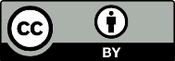Example Resource by Copyright Holder is licensed under a [Creative Commons Attribution 4.0 International License](http://creativecommons.org/licenses/by/4.0/).

Example for Adapted Work:

Example Resource is licensed under a [Creative Commons Attribution-NonCommercial-ShareAlike 4.0 International License](http://creativecommons.org/licenses/by/4.0/). This is a derivative work by Jane Doe adapted from Original Resource Name by Original Creator.

* Consider how you will share your OER. Options include:
  + [ARPDC New Curriculum Resource Site](https://arpdc.ab.ca/new-curriculum-resources/)
  + [OER Commons](https://oercommons.org/)

# Example of Completed OER

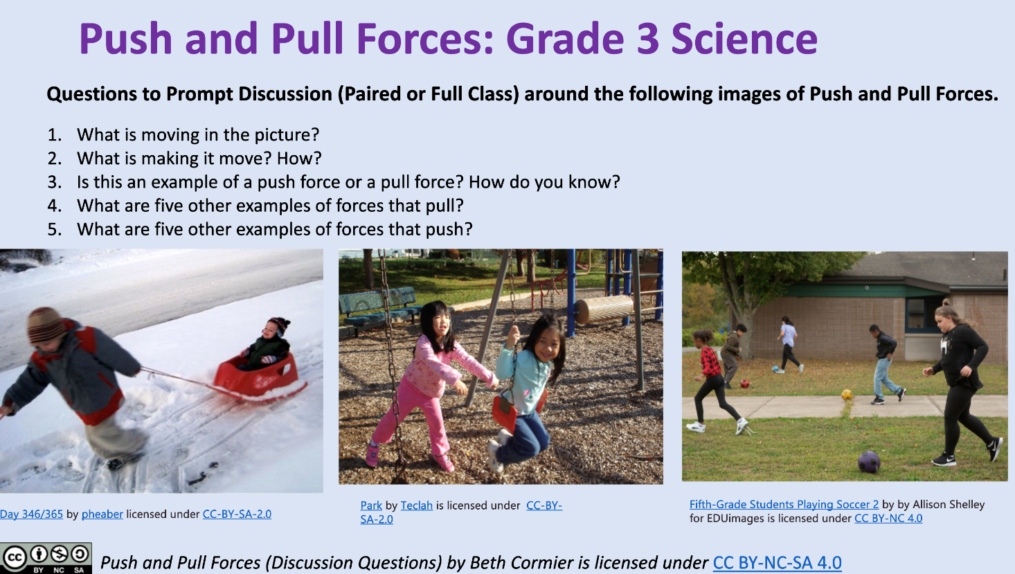

# Resources

[Best Practices in Attribution](https://wiki.creativecommons.org/wiki/Best_practices_for_attribution) | Creative Commons

[About CC Licenses](https://creativecommons.org/share-your-work/cclicenses/) | Creative Commons

[Choose a License](https://creativecommons.org/choose/) | Creative Commons

[Download Creative Commons License Logos](https://creativecommons.org/about/downloads) | Creative Commons

[Open Attribution Builder](https://www.openwa.org/attrib-builder/) | Open Washington - State Board for Community and Technical Colleges

# Important Terms

**Copyright** - the legal protection that gives the copyright owner the right to reproduce, adapt, distribute, display, and perform the work. Copyright covers both published and unpublished works. Works do not need to be registered.

**Copyright licenses -** outline the specific permissions and restrictions that a copyright holder grants to someone else.

**Open License** (e.g. [Creative Commons](https://creativecommons.org/)) – a license that grants permission to access, re-use and redistribute a work with few or no restrictions

**Attribution** – giving credit to a person or organization as the creator or copyright holder of a work. All open licenses have an attribution requirement.

**Citation** - allows authors to provide the source of any quotations, ideas, and information that they include in their own work based on the copyrighted works of other authors.

“Open Licensing Checklist” is adapted from “[Open Licensing Checklist](https://oercommons.org/courseware/lesson/73494/overview)” by Babara Soots, used under [CC BY 4.0](https://creativecommons.org/licenses/by/4.0/). Except where otherwise noted, this work “Open Licensing Checklist” by Kirsten Livingstone and Beth Cormier is licensed under [CC BY-NC 4.0](https://creativecommons.org/licenses/by-nc/4.0/).

*This document contains links to websites operated by third parties. These links are provided for your convenience only and do not constitute or imply any monitoring. Please confirm the license status of any third-party resources and understand their terms of use before reusing them.*

